# Assessment Three - RAD Final Project

# Daniel Swain 13/06/2016

## Module Tracking

For the Real Estate Website (website) we utilised various project management tools to track the tasks that were assigned to developers for each module or aspect of the website. As part of my responsibilities as Scrum Master it was my task to keep abreast of the progress of these modules and liaise with the Team Leader to remove blockages for any team member who was having problems completing a module.

Trello, Slack and GitHub were used to track the implementation of modules. Once a task/module was assigned to a developer that task was recorded on Trello with a notification being sent to them via Slack (automated via Zapier).

During the sprints I would regularly contact team members using Slack and would monitor GitHub commits for the progress of each developer with their modules. I would use Slack to provide guidance and seek updates on the progress of each module and use the in class Scrum meetings to follow up with developers face to face.

## Performance Tracking & Optimisation

Slack and GitHub were used to track the performance of code and perform optimisation in a similar fashion to how module progress was tracked. During the development and testing phase all team members regularly pulled their latest changes to the master branch, thereby allowing all team members to test the latest functionality.

Whenever I pulled the latest from master I would test to see if any new features had affected any existing modules and/or had introduced performance issues. If I identified an issue I would create a GitHub issue and assign the team member who developed that module. I would also provide examples on a suggested fix if I had identified one.

The following is an example from a GitHub issue I created during the project after noticing a JQuery selector overriding settings on dropdowns I had implemented prior to the latest updates to master. The issue is located on GitHub [here](https://github.com/slehmann36/Group3-Real-Estate-Site/issues/18). The screenshot of the issue on GitHub and the resulting code optimisation is featured below.

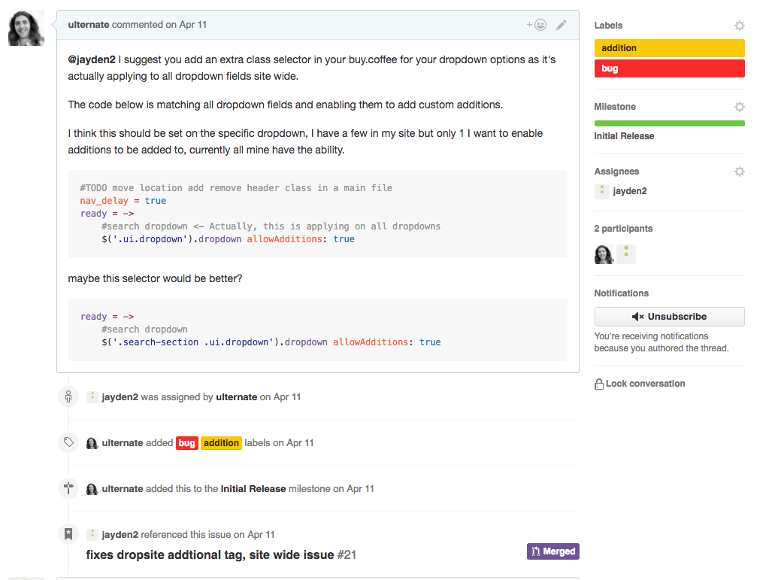

A screenshot of a GitHub issue created during the course of the project. In this issue I identified a suggested fix for the issue and included it in my issue body. I assigned it to the pertinent person and they implemented their version of the fix in their next merge request into master (as evidenced at the bottom of the image).

During the course of the project I created 24 GitHub issues, of which 22 were closed. I found GitHub as an effective tool for tracking and optimizing code for performance issues. Where I was unable to provide a code sample as a solution I would use Slack and discuss with the remaining team members in a subsequent Scrum meeting to get the group’s suggestions.

## User Comment Review

We received client/user feedback early on in the project with the approval of our initial designs on the 6th of April. The client had decided that overall, the bulk of our initial designs were to be used for the subsequent development, however we were to use a left sidebar on the search page and implement the other team’s property page layout.

After receiving this feedback, we requested the designs from the other teams as well as providing our chosen designs. These designs were distributed to team members via Slack and were used by developers as the final guidance for any tasks involving building the layout of those pages.

During the project lifecycle we regularly demoed the website to the customer/user stakeholder to receive feedback and suggestions on our progress. This process was invaluable in identifying critical areas of development. An example occurred at the conclusion of the third sprint. We discussed with the customer/user stakeholder the problems we were having with mobile responsiveness and the chance that it wouldn’t be ready for delivery. The customer/user stakeholder informed us that mobile responsiveness was a functional requirement for the site’s completion.

This feedback forced us to refocus the priorities we had placed upon certain tasks. We had prioritised features such as messaging that were not identified as part of the functional requirements of the site. After receiving this user feedback, the Team Leader and I shelved development on this and other features not seen by the user as functional requirements and refocused our development efforts on the modules required for final handover.

The continuous feedback cycle and the prompt handling of user comments allowed our team to keep momentum through the project and have the site completed to the functional requirements ahead of schedule to a high level of polish.

## Implementation & Handover Preparation

Trello was used as the main tool for setting the schedule for implementing each module. Prior to each Sprint review the Team Leader and I would review the remaining tasks for the site and draft the tasks list for the next sprint. We would look at the latest codebase for the project and identify the areas that were complete and which modules needed to be focused on in order to build towards satisfying all the functional requirements.

The following image is a screenshot of our Trello board. The project timeline runs from right to left.

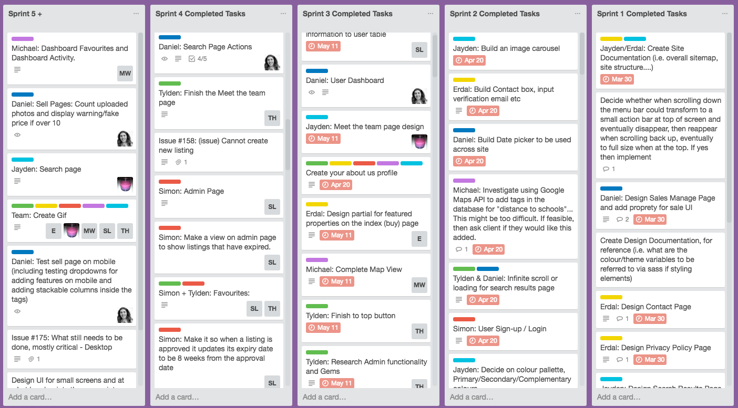

To build up the site in preparation for handover we slowly accelerated the complexity of our sprint tasks/module workload to reflect the changing understandings and growing confidence of team members in the new languages.

Early development tasks were focused on ‘easy wins’ for team members to build momentum. This involved tasks such as setting up site structure and navigation, implementing popular gems and starting to build overall layouts with mock data. Subsequent development tasks on site modules introduced more complexity at a reasonable pace.

This allowed the Team Leader and I to distribute tasks effectively and ramp up programming efforts to suit the task load remaining when compared against the functional requirements. This also involved coordinating team members to ensure that critical path items were completed early to reduce blockages for other team members.

Each Trello card would be added with a detailed description of the tasks required by the developer for the module to be marked as satisfactorily completed to the specifications. I would add each card with the tasks for the developer, whilst the schedule would be set during the sprint meeting where tasks were handed out.

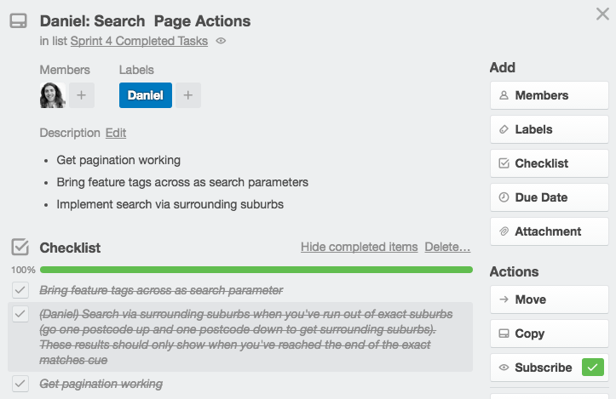

An example Trello card showing the task requirements and checklist for the developer.

Similar to the user feedback process, this regular progress review allowed team members to be fully aware of the tasks required to meet the functional requirements. It was valuable for continually narrowing the focus as we ticked off more and more of the functional requirements and resulted in the site being completed ahead of the initial deadline of the 9th of June.

## Handover Report

Please see the included Project Handover Report for a full accounting of the website’s final functionality, testing and validation of functional requirements.